Justin Guerra
Data Mining
Project 1.5

General Strategy
To start out I pre-processed the data quite a bit. I converted a lot of numeric values to nomial values. After this I started running clusters looking for trends. I eventually settled on exluding most of the data set, I ignored all of the diagnostic codes for example. I instead chose to focus on factors such as severity, length of stay, etc. I then started making clusters and through trial and error found what turned out to be decent looking clusters.
Description
I used two different clustering algorithms, and the same similarity metric for both interesting clusters I found. I chose to use Euclidean distance for a couple of reasons. First, I had no binary data, so it seemed like it would be a good fit. Second, it arbitrarily seemed to give me better results in my trial and error stage. And lastly, it was the most familiar metric to me. I used simply K-means for my first clustering. I chose my k-value to be 2. I came to this after trying with a variety of numbers. When I used five or six clusters I could not see any distinct clusters. As I lowered it though, a few clusters became apparent. The clusters were most obvious when I chose to use only two clusters. For my second clustering run I decided to switch up the method a bit. I used MakeDensityBasedClusterer. I used simple k-means to generate my clusters. From what I can tell from the API, MakeDensityBasedClusterer, wraps the clusterer from simple k-means, and returns a distribution and density. MakeDensityBasedClusterer gave me some very nice looking clusters.

Cluster #1
=== Run information ===

Scheme: weka.clusterers.SimpleKMeans -N 2 -A "weka.core.EuclideanDistance -R first-last" -I 500 -S 10
Relation: train-a-weka.filters.unsupervised.attribute.NumericToNominal-R7,8,9,11,12,13,48,49,53,71,77,79
Instances: 99999
Attributes: 79
Patient-Sex
Age
Patient-Disposition
Length of Stay
Admit-Type
Admit-Source
Cause-E-Code
Place-E-Code
TotalCharges
Serv-Class
Residence-Ind
Emergency-Dept-Ind
Complication-Minor
Complication-Sever
Trauma-Minor
Trauma-Severe
Trauma-Severity
Severity
Cost Weight
Ignored:
RecordID
PatientID
Record Count
Interval
Patient-Race
Patient-Ethnicity
Hospital-ID
Region-ID
Principal-Dx-Code
Admit-Dx-Code
Other-Dx-Code-1
Other-Dx-Code-2
Other-Dx-Code-3
Other-Dx-Code-4
Other-Dx-Code-5
Other-Dx-Code-6
Other-Dx-Code-7
Other-Dx-Code-8
Other-Dx-Code-9
Other-Dx-Code-10
Other-Dx-Code-11
Other-Dx-Code-12
Other-Dx-Code-13
Other-Dx-Code-14
Principal-PR-Code
Other-PR-Code-1
Other-PR-Code-2
Other-PR-Code-3
Other-PR-Code-4
Other-PR-Code-5
Other-PR-Code-6
Other-PR-Code-7
Other-PR-Code-8
Other-PR-Code-9
Other-PR-Code-10
Other-PR-Code-11
Other-PR-Code-12
Other-PR-Code-13
Other-PR-Code-14
Reimb DRG
Reimb MDC
AccomCharges
AncilCharges
CMC1
CMC2
CMC3
CMC4
CMC5
CMC6
CMC7
CMC8
CMC9
CMC10
PL1
PL2
PL3
PL4
PL5
Pot Amb
Nosocomial Inf
Test mode: evaluate on training data

=== Model and evaluation on training set ===

kMeans
======

Number of iterations: 8
Within cluster sum of squared errors: 271861.4379683066
Missing values globally replaced with mean/mode

Cluster centroids:
Cluster#
Attribute Full Data 0 1
(99999) (69720) (30279)
======================================================
Patient-Sex F F M
Age 72.7984 74.2061 69.5569
Patient-Disposition 1 1 1
Length of Stay 7.8484 6.9588 9.8968
Admit-Type 1 1 1
Admit-Source 7 7 1
Cause-E-Code E8788 E8788 E8788
Place-E-Code E8490 E8490 E8490
TotalCharges 33887.2846 26203.1993 51580.5513
Serv-Class 1 1 2
Residence-Ind H H H
Emergency-Dept-Ind E E E
Complication-Minor 0.5856 0.5753 0.6092
Complication-Sever 0.253 0.2192 0.331
Trauma-Minor 0.014 0.015 0.0115
Trauma-Severe 0.0379 0.0377 0.0382
Trauma-Severity 0.0812 0.0808 0.0821
Severity 3.8595 3.7165 4.1888
Cost Weight 0.98 0.98 0.98

Clustered Instances

0 69720 ( 70%)
1 30279 ( 30%)

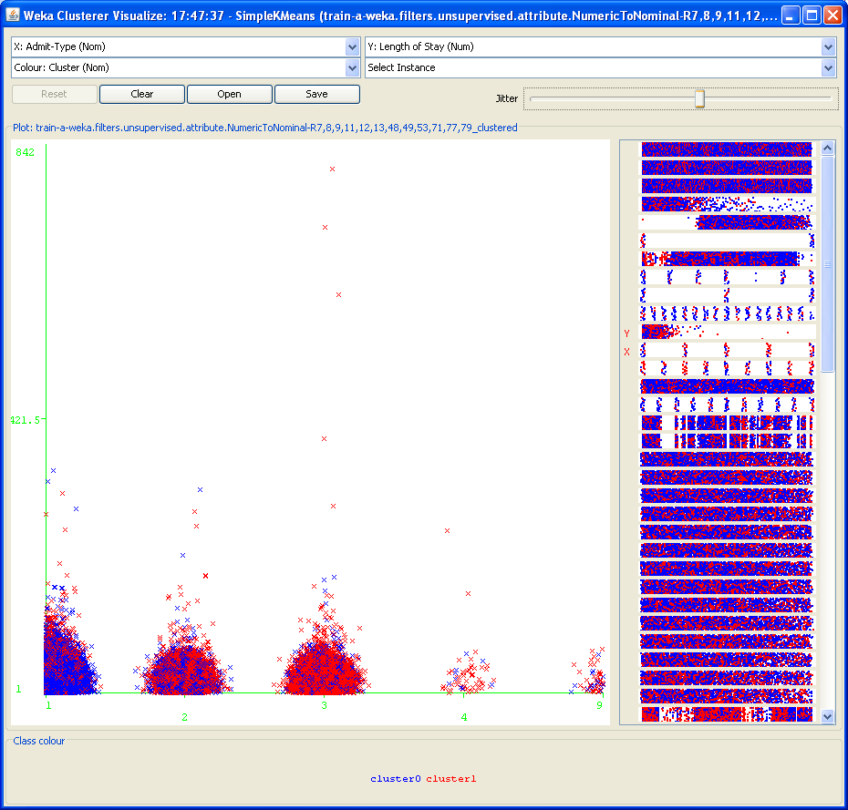

The clusters discovered show that cluster0 is predominately admitted for emergencies and other urgent situations. Cluster0, on average, is older and is admitted mostly for emergencies. Cluster1, on the other hand, is admitted more by a physician. This makes sense since they are mostly in the elective and urgent categories. Also the average total cost for cluster1 is almost twice as much as cluster0. Another interesting thing I found was that cluster1 has a longer length of stay, and its averages for complications and trauma are all slightly higher than for cluster0.

Cluster #2
=== Run information ===

Scheme: weka.clusterers.MakeDensityBasedClusterer -M 1.0E-6 -W weka.clusterers.SimpleKMeans -- -N 2 -A "weka.core.EuclideanDistance -R first-last" -I 500 -S 10
Relation: train-a-weka.filters.unsupervised.attribute.NumericToNominal-R7,8,9,11,12,13,48,49,53,71,77,79
Instances: 99999
Attributes: 79
Patient-Sex
Age
Patient-Disposition
Length of Stay
Admit-Type
Admit-Source
Cause-E-Code
Place-E-Code
TotalCharges
Serv-Class
Residence-Ind
Emergency-Dept-Ind
Complication-Minor
Complication-Sever
Trauma-Minor
Trauma-Severe
Trauma-Severity
Severity
Cost Weight
Ignored:
RecordID
PatientID
Record Count
Interval
Patient-Race
Patient-Ethnicity
Hospital-ID
Region-ID
Principal-Dx-Code
Admit-Dx-Code
Other-Dx-Code-1
Other-Dx-Code-2
Other-Dx-Code-3
Other-Dx-Code-4
Other-Dx-Code-5
Other-Dx-Code-6
Other-Dx-Code-7
Other-Dx-Code-8
Other-Dx-Code-9
Other-Dx-Code-10
Other-Dx-Code-11
Other-Dx-Code-12
Other-Dx-Code-13
Other-Dx-Code-14
Principal-PR-Code
Other-PR-Code-1
Other-PR-Code-2
Other-PR-Code-3
Other-PR-Code-4
Other-PR-Code-5
Other-PR-Code-6
Other-PR-Code-7
Other-PR-Code-8
Other-PR-Code-9
Other-PR-Code-10
Other-PR-Code-11
Other-PR-Code-12
Other-PR-Code-13
Other-PR-Code-14
Reimb DRG
Reimb MDC
AccomCharges
AncilCharges
CMC1
CMC2
CMC3
CMC4
CMC5
CMC6
CMC7
CMC8
CMC9
CMC10
PL1
PL2
PL3
PL4
PL5
Pot Amb
Nosocomial Inf
Test mode: evaluate on training data

=== Model and evaluation on training set ===

MakeDensityBasedClusterer:

Wrapped clusterer:
kMeans
======

Number of iterations: 8
Within cluster sum of squared errors: 271861.4379683066
Missing values globally replaced with mean/mode

Cluster centroids:
Cluster#
Attribute Full Data 0 1
(99999) (69720) (30279)
======================================================
Patient-Sex F F M
Age 72.7984 74.2061 69.5569
Patient-Disposition 1 1 1
Length of Stay 7.8484 6.9588 9.8968
Admit-Type 1 1 1
Admit-Source 7 7 1
Cause-E-Code E8788 E8788 E8788
Place-E-Code E8490 E8490 E8490
TotalCharges 33887.2846 26203.1993 51580.5513
Serv-Class 1 1 2
Residence-Ind H H H
Emergency-Dept-Ind E E E
Complication-Minor 0.5856 0.5753 0.6092
Complication-Sever 0.253 0.2192 0.331
Trauma-Minor 0.014 0.015 0.0115
Trauma-Severe 0.0379 0.0377 0.0382
Trauma-Severity 0.0812 0.0808 0.0821
Severity 3.8595 3.7165 4.1888
Cost Weight 0.98 0.98 0.98

Fitted estimators (with ML estimates of variance):

Cluster: 0 Prior probability: 0.6972

Attribute: Patient-Sex
Discrete Estimator. Counts = 21948 47774 (Total = 69722)
Attribute: Age
Normal Distribution. Mean = 74.2061 StdDev = 14.3017
Attribute: Patient-Disposition
Discrete Estimator. Counts = 29458 3131 15260 458 901 15808 1212 128 1446 16 174 170 166 1283 56 64 6 (Total = 69737)
Attribute: Length of Stay
Normal Distribution. Mean = 6.9588 StdDev = 8.0963
Attribute: Admit-Type
Discrete Estimator. Counts = 63896 3619 2181 11 18 (Total = 69725)
Attribute: Admit-Source
Discrete Estimator. Counts = 3291 461 86 1698 1173 278 62616 11 115 (Total = 69729)
Attribute: Cause-E-Code
Discrete Estimator. Counts = 1028 29 55 520 10 188 62786 473 566 92 53 157 3 89 999 77 17 567 15 23 94 338 48 27 46 43 9 57 35 4 151 66 42 51 12 7 126 2 9 23 3 26 65 1 7 4 2 31 18 2 2 9 19 26 2 59 36 4 8 2 1 8 2 2 6 12 8 8 11 14 7 13 2 4 2 23 12 6 3 5 4 5 11 4 2 8 4 4 19 11 7 3 1 4 12 2 5 2 2 2 2 3 6 16 4 3 2 6 2 7 3 2 1 2 5 1 3 4 6 1 2 7 1 2 6 2 1 6 1 24 4 3 3 19 5 2 5 3 4 4 2 19 5 2 2 4 3 4 2 5 3 3 3 1 2 1 1 3 4 2 4 4 3 2 1 2 2 3 2 3 6 3 2 2 1 2 6 2 1 1 1 3 2 2 2 3 1 3 3 2 2 2 2 2 2 2 2 1 3 2 4 1 1 1 2 2 2 3 1 3 2 2 1 1 2 2 2 5 3 2 2 2 2 1 2 1 2 2 2 2 2 1 1 3 2 2 2 2 2 1 2 2 1 2 2 1 2 3 1 2 1 1 2 2 (Total = 69974)
Attribute: Place-E-Code
Discrete Estimator. Counts = 98 67717 788 638 391 80 7 7 3 (Total = 69729)
Attribute: TotalCharges
Normal Distribution. Mean = 26203.1993 StdDev = 38684.3567
Attribute: Serv-Class
Discrete Estimator. Counts = 53995 14560 114 72 9 976 (Total = 69726)
Attribute: Residence-Ind
Discrete Estimator. Counts = 69339 383 (Total = 69722)
Attribute: Emergency-Dept-Ind
Discrete Estimator. Counts = 69721 (Total = 69721)
Attribute: Complication-Minor
Normal Distribution. Mean = 0.5753 StdDev = 0.7791
Attribute: Complication-Sever
Normal Distribution. Mean = 0.2192 StdDev = 0.5438
Attribute: Trauma-Minor
Normal Distribution. Mean = 0.015 StdDev = 0.1288
Attribute: Trauma-Severe
Normal Distribution. Mean = 0.0377 StdDev = 0.2184
Attribute: Trauma-Severity
Normal Distribution. Mean = 0.0808 StdDev = 0.3957
Attribute: Severity
Normal Distribution. Mean = 3.7165 StdDev = 1.7131
Attribute: Cost Weight
Discrete Estimator. Counts = 35 135 149 4 10 2 6 5 9 2 14 6 7 6 2 8 2 19 3 3 2 39 2 2 6 71 252 156 13 21 22 31 10 11 3 7 11 45 8 55 89 10 80 2 14 20 14 26 48 29 89 73 612 301 37 198 126 64 36 77 39 67 65 43 102 131 53 98 111 107 78 100 97 175 95 235 479 314 169 94 101 128 109 83 73 1240 122 70 100 193 176 2014 205 688 174 234 219 104 176 187 140 175 299 232 941 530 253 206 204 158 289 222 283 363 991 595 392 348 275 443 270 283 280 334 358 297 341 242 330 260 368 358 361 271 389 323 469 412 300 414 399 395 296 459 354 289 204 237 307 465 330 274 293 313 249 415 417 319 332 519 330 320 275 267 292 268 335 331 298 323 290 300 299 263 233 242 270 343 292 249 256 277 280 231 275 236 248 230 250 241 240 250 219 520 210 260 213 251 286 234 260 235 344 245 235 237 182 248 294 192 326 264 196 238 210 236 202 353 194 189 203 179 241 195 180 188 199 162 166 200 190 206 193 188 174 270 196 194 189 191 148 170 177 159 168 143 145 182 184 179 147 140 164 144 151 194 148 124 213 147 136 152 146 129 134 136 115 145 102 131 191 112 150 133 131 138 114 115 101 115 129 135 94 94 134 129 123 138 100 98 136 94 77 99 104 110 85 105 101 101 108 101 75 94 83 93 79 90 85 96 93 76 94 96 75 90 100 81 76 69 78 77 70 79 72 78 78 68 70 72 87 74 62 61 83 75 81 66 58 61 64 72 76 66 71 40 64 65 40 67 61 68 58 42 50 44 55 60 49 47 49 49 67 53 58 64 51 56 60 43 51 43 37 51 52 46 46 46 51 41 49 31 37 42 32 39 37 53 35 35 29 46 39 42 28 53 43 36 36 34 32 37 48 28 38 33 35 44 30 31 31 26 22 24 32 57 31 28 40 30 28 35 22 22 34 29 33 31 32 26 36 32 33 37 29 29 25 32 23 40 24 16 23 32 22 19 16 13 21 14 28 11 24 21 24 22 20 19 22 23 15 25 25 16 12 20 15 16 15 18 15 18 24 15 14 15 12 9 9 15 10 15 6 15 22 18 18 17 12 15 14 22 18 17 6 18 9 13 11 6 8 17 14 10 16 5 9 11 12 9 16 46 16 9 12 15 8 11 10 10 6 15 8 16 9 6 9 11 10 7 6 3 6 10 5 11 6 10 9 9 6 6 7 11 8 4 4 5 7 8 7 7 4 4 11 9 6 5 5 7 6 7 5 4 6 4 1 6 5 7 7 5 4 6 4 2 4 6 4 3 5 6 3 2 3 4 2 4 3 5 5 3 3 3 4 7 1 3 1 2 5 5 3 3 4 1 6 3 2 3 3 3 3 4 3 5 3 1 3 5 4 3 5 1 2 4 5 3 3 3 2 3 3 3 1 3 1 3 5 1 1 2 2 4 5 5 2 2 2 2 4 1 3 4 1 1 1 2 2 1 1 2 1 3 1 2 1 1 2 1 2 2 2 4 2 1 1 2 1 1 2 1 1 1 2 2 1 2 1 1 2 2 1 4 1 1 1 1 1 2 1 1 1 2 2 1 2 1 1 2 1 1 2 3 2 2 2 1 1 1 1 2 1 1 1 1 2 2 1 1 2 1 1 1 1 1 1 3 2 1 1 2 1 3 1 1 1 1 1 2 1 1 3 2 1 1 1 2 1 1 2 4 1 1 1 1 1 3 2 1 1 1 1 1 1 1 1 1 1 2 2 1 1 2 1 1 2 1 2 2 2 2 1 1 1 1 1 1 1 1 2 1 1 1 2 1 1 2 1 1 1 2 1 1 1 1 2 1 2 2 2 2 2 2 2 2 1 1 1 1 2 1 2 1 1 1 2 1 2 1 2 1 3 1 1 2 2 2 1 2 1 2 1 2 1 2 2 1 2 1 2 1 1 1 1 2 1 2 2 2 1 1 1 2 1 1 1 2 2 1 2 1 2 2 1 1 3 1 2 2 2 1 1 3 2 1 1 1 1 1 1 2 1 1 1 1 1 1 1 1 1 1 2 1 1 1 1 1 1 1 1 1 1 1 1 1 1 1 1 1 1 1 1 1 1 1 1 1 1 1 1 1 1 1 1 1 1 2 1 1 1 1 1 2 1 1 1 1 1 1 1 1 2 1 (Total = 70684)

Cluster: 1 Prior probability: 0.3028

Attribute: Patient-Sex
Discrete Estimator. Counts = 23878 6403 (Total = 30281)
Attribute: Age
Normal Distribution. Mean = 69.5569 StdDev = 14.9813
Attribute: Patient-Disposition
Discrete Estimator. Counts = 14545 1074 5705 119 429 5915 291 94 759 12 46 66 47 1127 38 28 1 (Total = 30296)
Attribute: Length of Stay
Normal Distribution. Mean = 9.8968 StdDev = 14.7615
Attribute: Admit-Type
Discrete Estimator. Counts = 16917 5571 7700 54 42 (Total = 30284)
Attribute: Admit-Source
Discrete Estimator. Counts = 13331 714 145 2214 909 235 12493 18 229 (Total = 30288)
Attribute: Cause-E-Code
Discrete Estimator. Counts = 374 11 18 1029 5 48 24589 964 586 227 18 135 5 273 301 151 16 180 1 5 188 180 23 31 21 12 3 58 18 1 220 21 59 10 20 13 55 1 13 5 7 8 35 2 5 1 2 37 8 2 1 4 6 17 2 37 14 1 4 2 4 8 1 1 3 36 5 5 2 3 3 18 1 3 1 10 3 3 3 4 3 1 6 1 1 4 1 8 4 9 5 1 4 2 4 1 1 1 1 1 2 1 4 15 1 2 1 3 1 2 2 2 2 1 1 6 1 3 4 2 2 5 2 1 3 1 3 1 3 3 1 4 1 1 1 1 2 1 1 2 1 1 2 2 1 2 2 3 1 1 2 1 1 2 1 3 2 1 2 1 2 4 1 2 2 1 1 1 1 1 7 1 1 1 3 3 2 1 2 2 2 1 1 2 1 1 3 2 1 1 1 1 1 1 1 2 1 3 1 2 1 2 2 2 2 1 2 2 3 1 1 1 2 2 1 1 1 2 2 1 1 1 1 2 2 2 2 1 1 2 1 2 2 1 1 1 1 1 1 2 1 1 2 1 1 2 1 1 2 1 2 2 1 1 (Total = 30533)
Attribute: Place-E-Code
Discrete Estimator. Counts = 38 29270 441 294 196 30 9 8 2 (Total = 30288)
Attribute: TotalCharges
Normal Distribution. Mean = 51580.5513 StdDev = 76531.8753
Attribute: Serv-Class
Discrete Estimator. Counts = 3139 26152 213 13 55 713 (Total = 30285)
Attribute: Residence-Ind
Discrete Estimator. Counts = 30134 147 (Total = 30281)
Attribute: Emergency-Dept-Ind
Discrete Estimator. Counts = 30280 (Total = 30280)
Attribute: Complication-Minor
Normal Distribution. Mean = 0.6092 StdDev = 0.8127
Attribute: Complication-Sever
Normal Distribution. Mean = 0.331 StdDev = 0.711
Attribute: Trauma-Minor
Normal Distribution. Mean = 0.0115 StdDev = 0.1119
Attribute: Trauma-Severe
Normal Distribution. Mean = 0.0382 StdDev = 0.2209
Attribute: Trauma-Severity
Normal Distribution. Mean = 0.0821 StdDev = 0.4146
Attribute: Severity
Normal Distribution. Mean = 4.1888 StdDev = 1.8531
Attribute: Cost Weight
Discrete Estimator. Counts = 6 24 21 2 4 1 1 3 1 1 8 1 1 3 5 2 2 1 2 4 1 32 1 2 5 24 52 22 8 5 5 5 3 4 3 3 3 7 1 5 29 4 28 10 7 4 3 9 11 11 21 28 91 46 13 31 13 21 18 18 7 9 24 8 27 67 7 15 21 20 11 17 16 17 62 36 273 129 33 19 39 23 24 18 13 210 32 12 16 37 35 679 53 71 65 52 36 32 39 49 36 26 49 48 206 80 68 100 41 57 113 90 85 179 134 232 59 75 56 81 69 86 51 122 91 86 95 79 118 65 101 87 63 72 78 94 128 96 77 75 93 119 67 126 135 81 79 77 92 189 131 111 108 105 94 111 177 94 88 190 95 106 85 79 119 106 149 115 98 106 95 92 113 82 90 92 88 116 99 107 94 116 68 81 87 87 85 104 86 99 86 114 69 124 96 91 64 83 83 97 102 90 89 101 80 89 109 92 87 63 105 116 80 83 75 204 101 121 81 99 125 97 94 90 59 76 98 73 87 80 65 85 86 92 86 99 106 89 81 85 84 84 78 73 87 86 61 65 108 89 73 74 71 70 70 79 58 55 86 90 85 65 78 67 56 75 77 71 60 57 88 66 63 67 83 78 49 73 68 63 61 68 68 67 62 60 118 83 57 60 68 95 56 66 64 49 63 52 66 73 48 56 70 59 59 59 63 66 78 47 38 42 64 48 54 49 57 39 65 59 59 36 56 54 47 54 41 51 58 48 45 63 41 51 56 58 51 47 41 62 41 43 49 90 52 44 54 53 47 42 41 52 39 44 34 40 33 38 43 38 41 38 34 33 37 120 40 38 70 35 29 42 26 32 27 25 28 34 45 27 40 30 42 32 35 41 41 33 29 32 29 28 35 28 35 43 39 32 27 40 28 32 35 35 43 37 25 30 21 30 28 36 25 30 44 189 70 35 28 33 26 25 32 31 29 28 43 70 40 40 28 32 38 189 34 30 32 49 22 24 25 22 31 25 21 22 29 29 42 18 75 16 27 31 12 33 22 29 25 20 32 59 37 22 22 20 23 25 24 19 27 24 16 33 28 23 17 19 18 24 25 16 20 36 13 19 24 25 16 19 15 17 14 86 27 18 12 18 16 18 13 11 16 18 17 16 22 18 37 13 14 199 38 25 21 61 20 17 23 17 15 29 18 34 32 25 10 26 8 13 23 10 13 19 15 31 19 17 12 17 20 13 9 20 20 11 17 16 21 9 17 25 13 15 12 20 9 30 25 15 8 9 4 12 7 14 12 14 14 9 12 12 10 18 10 9 8 6 4 9 26 8 11 15 9 9 9 5 6 10 10 2 12 14 11 7 3 7 8 7 10 10 8 5 10 16 6 9 10 6 10 8 5 8 7 5 7 5 6 13 5 6 7 6 7 3 7 4 8 9 5 4 3 6 5 5 4 10 7 7 4 5 4 5 4 4 5 4 5 3 6 2 3 3 4 5 6 3 4 3 2 4 4 4 5 3 6 9 4 2 2 4 5 5 7 5 5 1 2 4 6 3 2 3 3 4 5 2 5 7 1 1 4 2 3 3 6 3 4 2 2 4 3 2 4 2 4 3 3 5 4 3 2 1 1 3 3 3 3 2 3 4 2 2 2 3 4 1 3 2 3 4 2 2 4 2 3 1 1 3 2 2 2 1 2 4 4 2 2 2 3 3 1 1 2 2 3 1 2 4 3 2 2 2 2 2 2 2 2 2 2 2 2 2 2 3 2 2 2 1 1 2 2 1 2 2 1 3 1 2 1 1 2 2 2 2 2 2 2 3 2 3 2 2 1 2 3 1 2 2 2 3 2 4 2 2 2 2 1 2 1 1 1 1 1 1 2 2 2 2 1 2 1 2 3 2 2 2 3 2 1 2 1 2 2 2 1 1 2 1 2 2 2 1 2 1 1 2 1 3 2 2 2 2 2 1 2 1 1 1 2 2 2 1 2 2 2 2 1 2 1 2 2 1 2 2 2 2 1 1 1 2 2 1 1 2 2 2 2 2 2 1 2 2 2 2 2 2 2 3 2 2 1 2 2 3 2 2 2 2 2 2 2 2 2 2 2 2 2 2 2 3 4 2 2 2 2 2 2 2 2 2 2 2 2 3 2 1 2 2 2 2 2 1 2 2 2 2 2 2 2 2 1 2 (Total = 31243)
Clustered Instances

0 75701 ( 76%)
1 24298 ( 24%)

Log likelihood: -34.5525

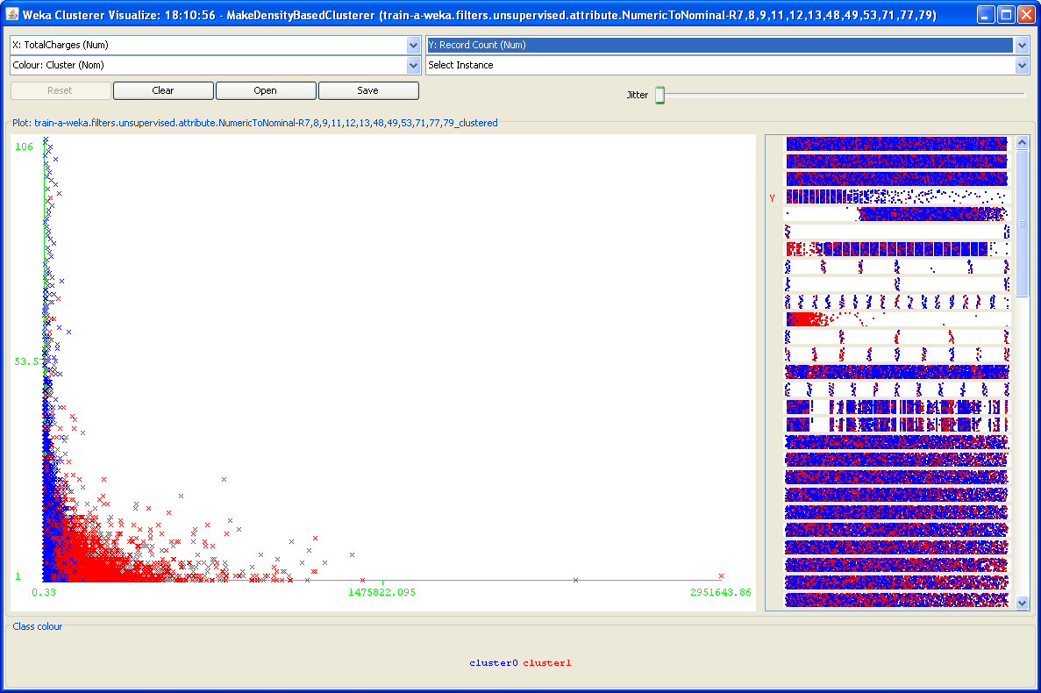

These clusters show that the cost goes up quite a bit for people who are on repeat visits. This also seems to be related to the amount of complications, trauma, and overall severity. For example, if you have a complication its likely you will have to visit again. In addition, the length of stay goes up quite a bit along with those same factors.

